Extra Credit Assignment 3
Please read turn-in checklist at the end of this document before you start doing exercises.

- a) Trace Dijkstra’s algorithm on the following graph to find supposedly shortest paths from vertex A to every other vertex. List the vertices in the order which you added them to the shortest path tree.

A - 0
B - 2
C - 7
D - 3
E - 9
F - 5
G - 2

Path taken: A, B, D, F, G, C, E

b) The graph has negative weight edges – the Dijkstra’s algorithm only works for graph with non-negative weight. Therefore, in the results from a), Dijkstra’s algorithm may find the wrong path to some of the vertices. For just the vertices where the wrong path was computed, indicate both the path that was computed and the correct path.

A - 0
B - 2
C - 7
D - 4 (computed path: A,C,E,G,D/ Correct path: A,B,D)
E - 9
F - 6 (computed path: A,C,E,G,D,F/ Correct path: A,B,D,F)
G - 8 (computed path: A,C,E,G/ Correct path: A,B,D,F,G)

Path taken: A, B, D, F, G, C, E

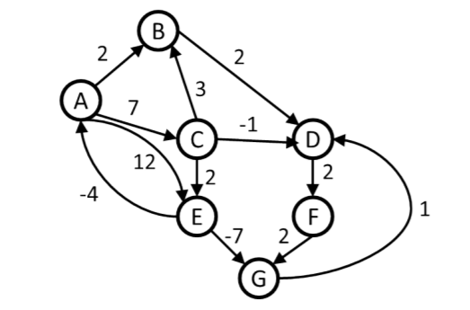

TURN-IN CHECKLIST:

- Your solution to P1(doc/pdf/txt). Remember to include your name, the date, and the course number in comments near the beginning of your code/report.

- Create a folder and name it 'FirstName_LastName_extra_credit_assignment_3'. In the newly created folder copy and paste your files (.doc/.txt/.java files). Then compress the folder, and push it to iLearn.

